Jeff Wilson

Homework Week 5 – Pyber – With Observations

Tuesday, March 20, 2018

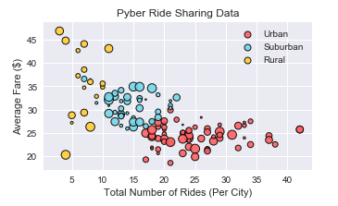

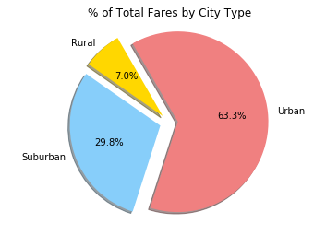

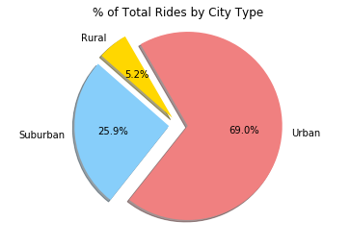

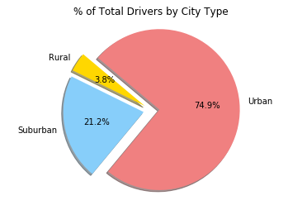

Observations:

There is far more demand for Pyber service in urban and then suburban areas. There are fewer drivers in rural areas, and there are fewer passengers. This should make intuitive sense.

The average fares for rural areas are higher, likely due to trips being longer since rural areas tend to be more spread out. Next your suburban fares are a little lower on average than rural fares, likely due to trips being a little shorter. Suburban areas are denser than rural areas. Urban fares on average are the lowest. Urban areas are denser than both rural and suburban areas, likely resulting in shorter trips than the other two.

Urban areas have the highest ridership, and the most drivers. This is likely related to the sheer population of urban areas. The higher the population the more demand there is for the service, and the more drivers who will be willing to drive for Pyber. Further, people who live in urban areas may opt to not own their own transportation, compared to suburban and rural areas. This will also lead to increased demand for services in urban areas versus suburban and rural areas.